**Real-Time Vehicle Detection and Collision Risk Estimation Using YOLO and Depth Integration**

**Overview**

This project presents a real-time vehicle detection system enhanced with depth-based distance estimation to improve spatial awareness in road scenes. By combining YOLO object detection with depth information from the KITTI dataset, the system moves beyond basic recognition to perception-driven analysis suitable for intelligent transportation and Advanced Driver Assistance Systems (ADAS).

**Objective**

The primary objective is to develop a computationally efficient system capable of:

• Detecting vehicles in real time

• Estimating their distance from the camera

• Evaluating collision risk dynamically

**Dataset**

The KITTI dataset, widely used in autonomous driving research, was utilized for training and evaluation.

Data leveraged:

• RGB images for object detection

• Ground-truth depth maps for distance estimation

This combination enables accurate real-world spatial measurements.

**Methodology**

**Object Detection**

YOLO was selected due to its single-stage architecture, enabling high-speed inference while maintaining strong detection accuracy.

**Depth-Based Distance Estimation**

For each detected vehicle:

1. Bounding box coordinates were extracted.

2. Corresponding depth pixels were retrieved.

3. Invalid values were removed.

4. Median depth was computed to ensure stable distance estimation.

**Collision Risk Modeling**

A dynamic risk scoring mechanism was introduced by combining estimated depth and bounding box area (used as a proxy for proximity).

**Risk Score Formula:**

Risk = (0.6 × Depth) + (0.4 × Bounding Box Area)

Objects were categorized into three risk levels:

• High Risk

• Medium Risk

• Safe

This approach transforms the system from a detection model into a perception-oriented safety prototype.

**Detection Output :**

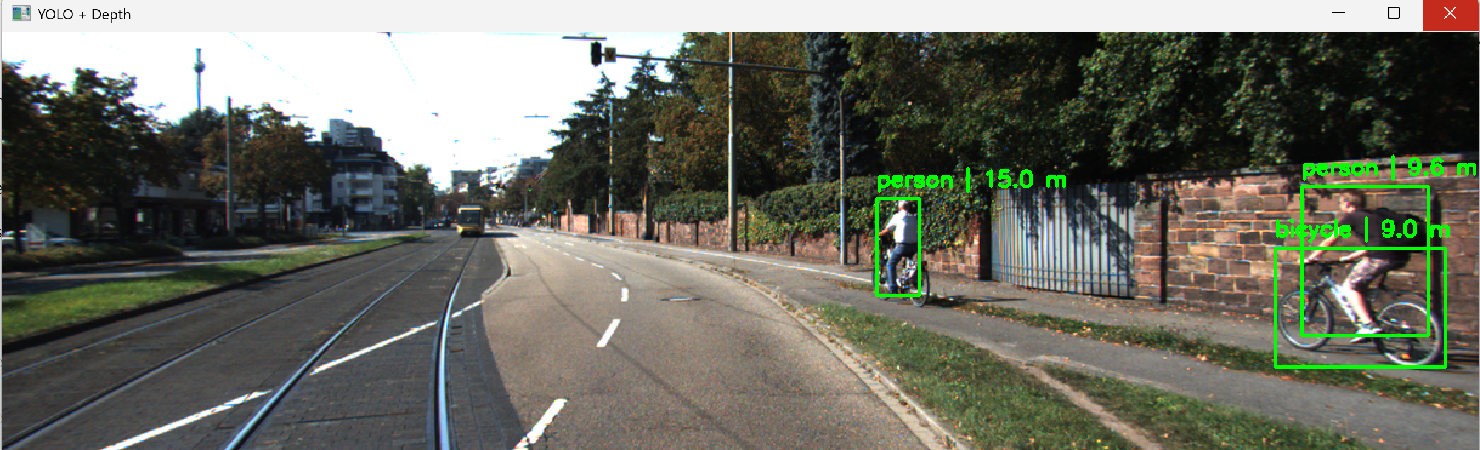

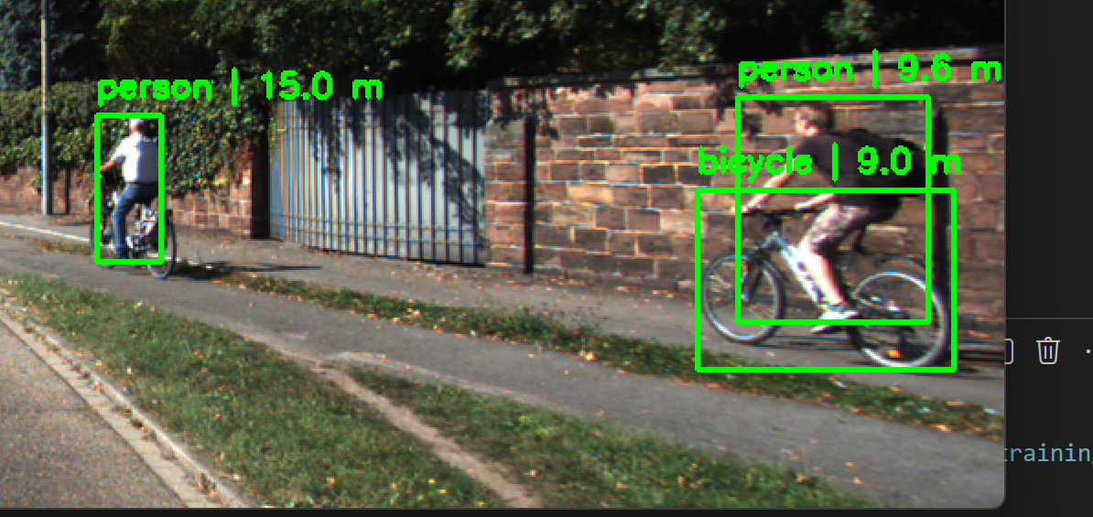

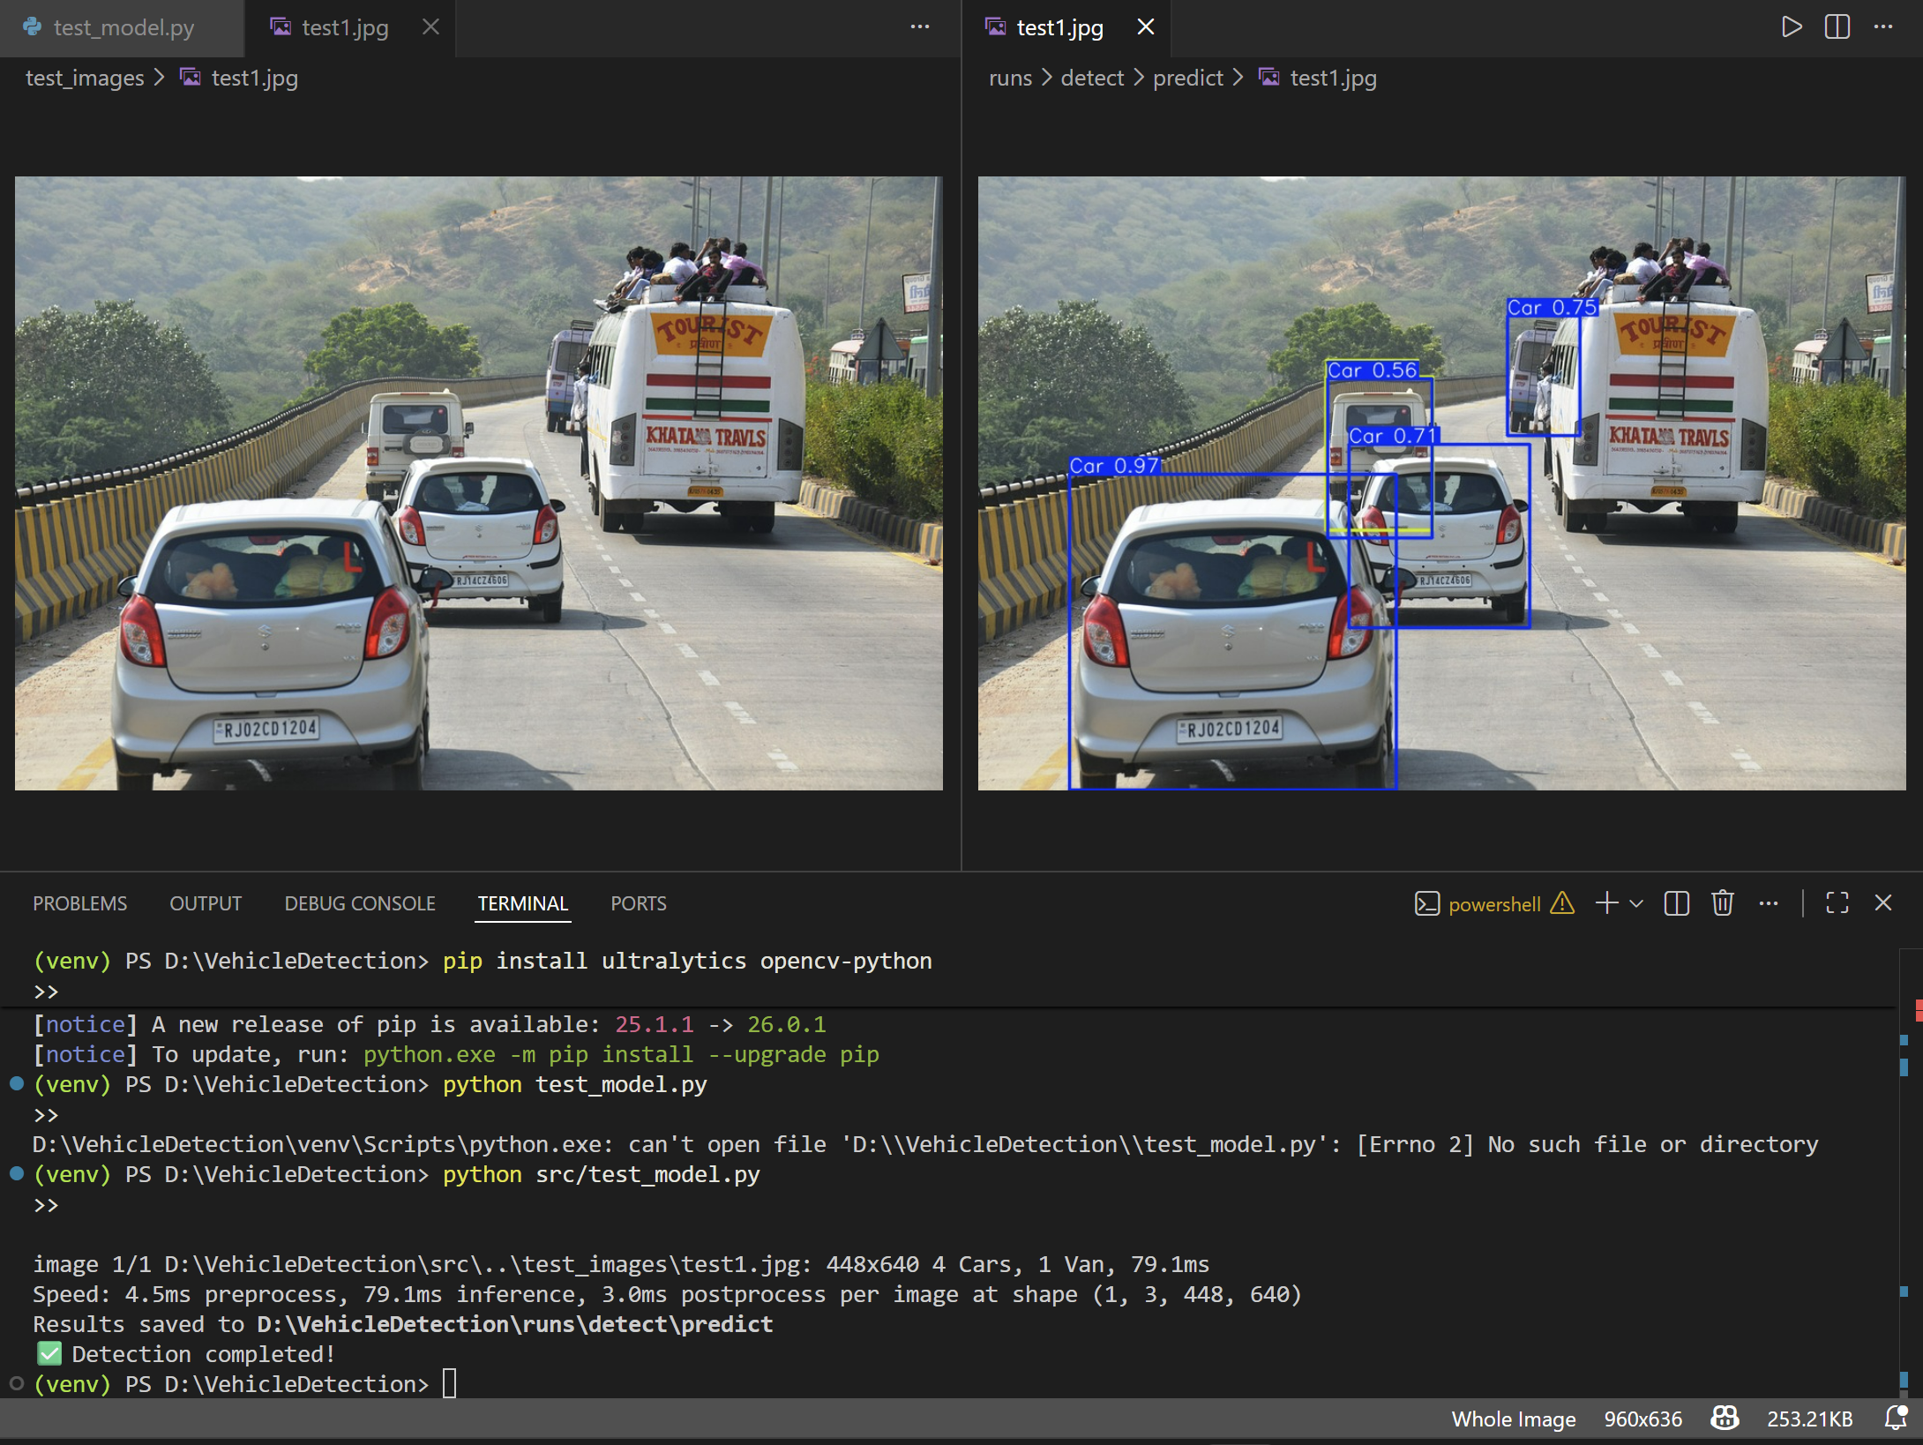

**Performance Evaluation**

| **Metric** | **Value** |
| --- | --- |
| **Precision** | **0.55** |
| **Recall** | **0.42** |
| **mAP@50** | **0.448** |
| **mAP@50–95** | **0.262** |
| **Total Images (Validation)** | 225 |
| **Total Instances** | 1564 |
| **Inference Time** | ~2.3 ms per image |
| **Post-processing Time** | ~4.7 ms per image |

**Detection Performance Curves and Confidence Analysis :**

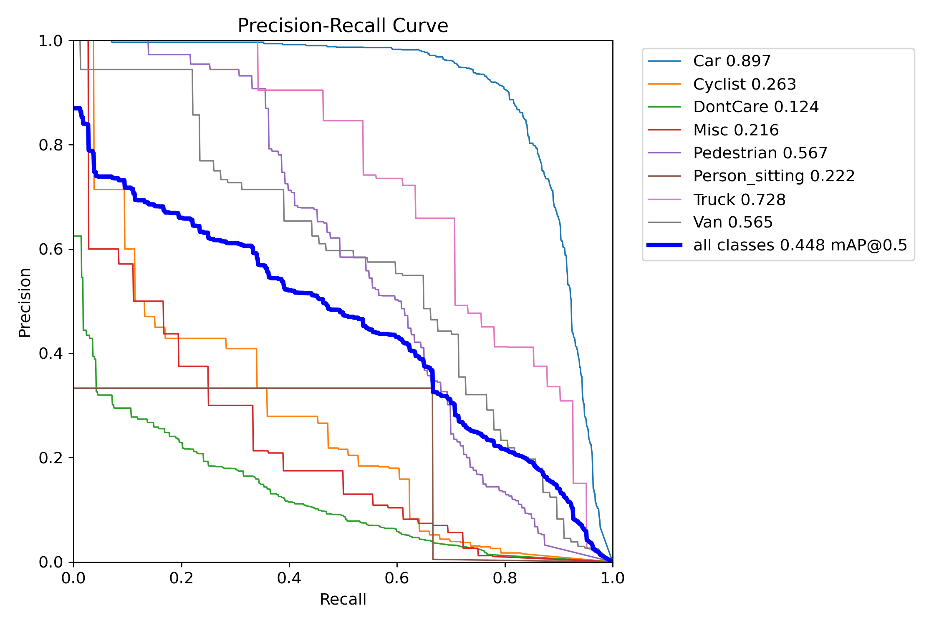 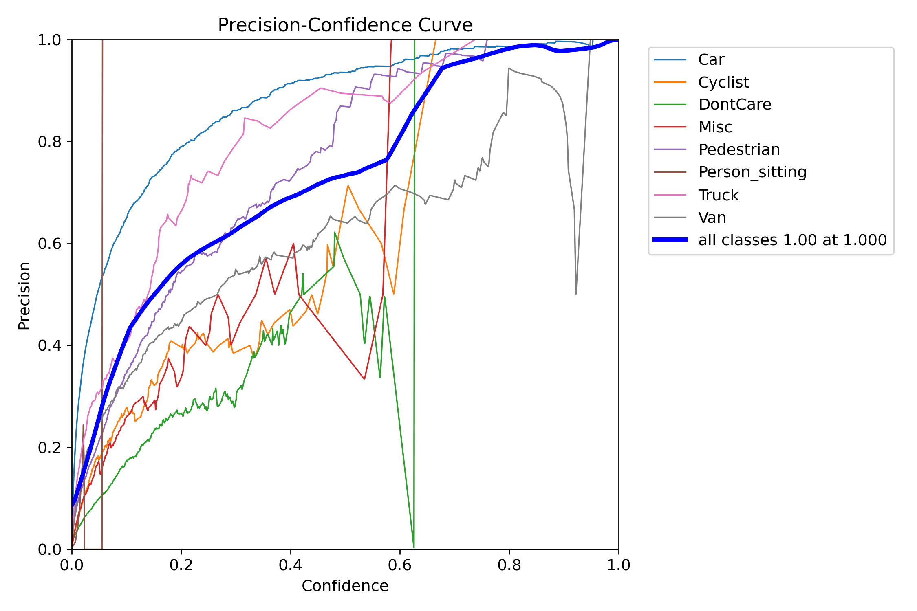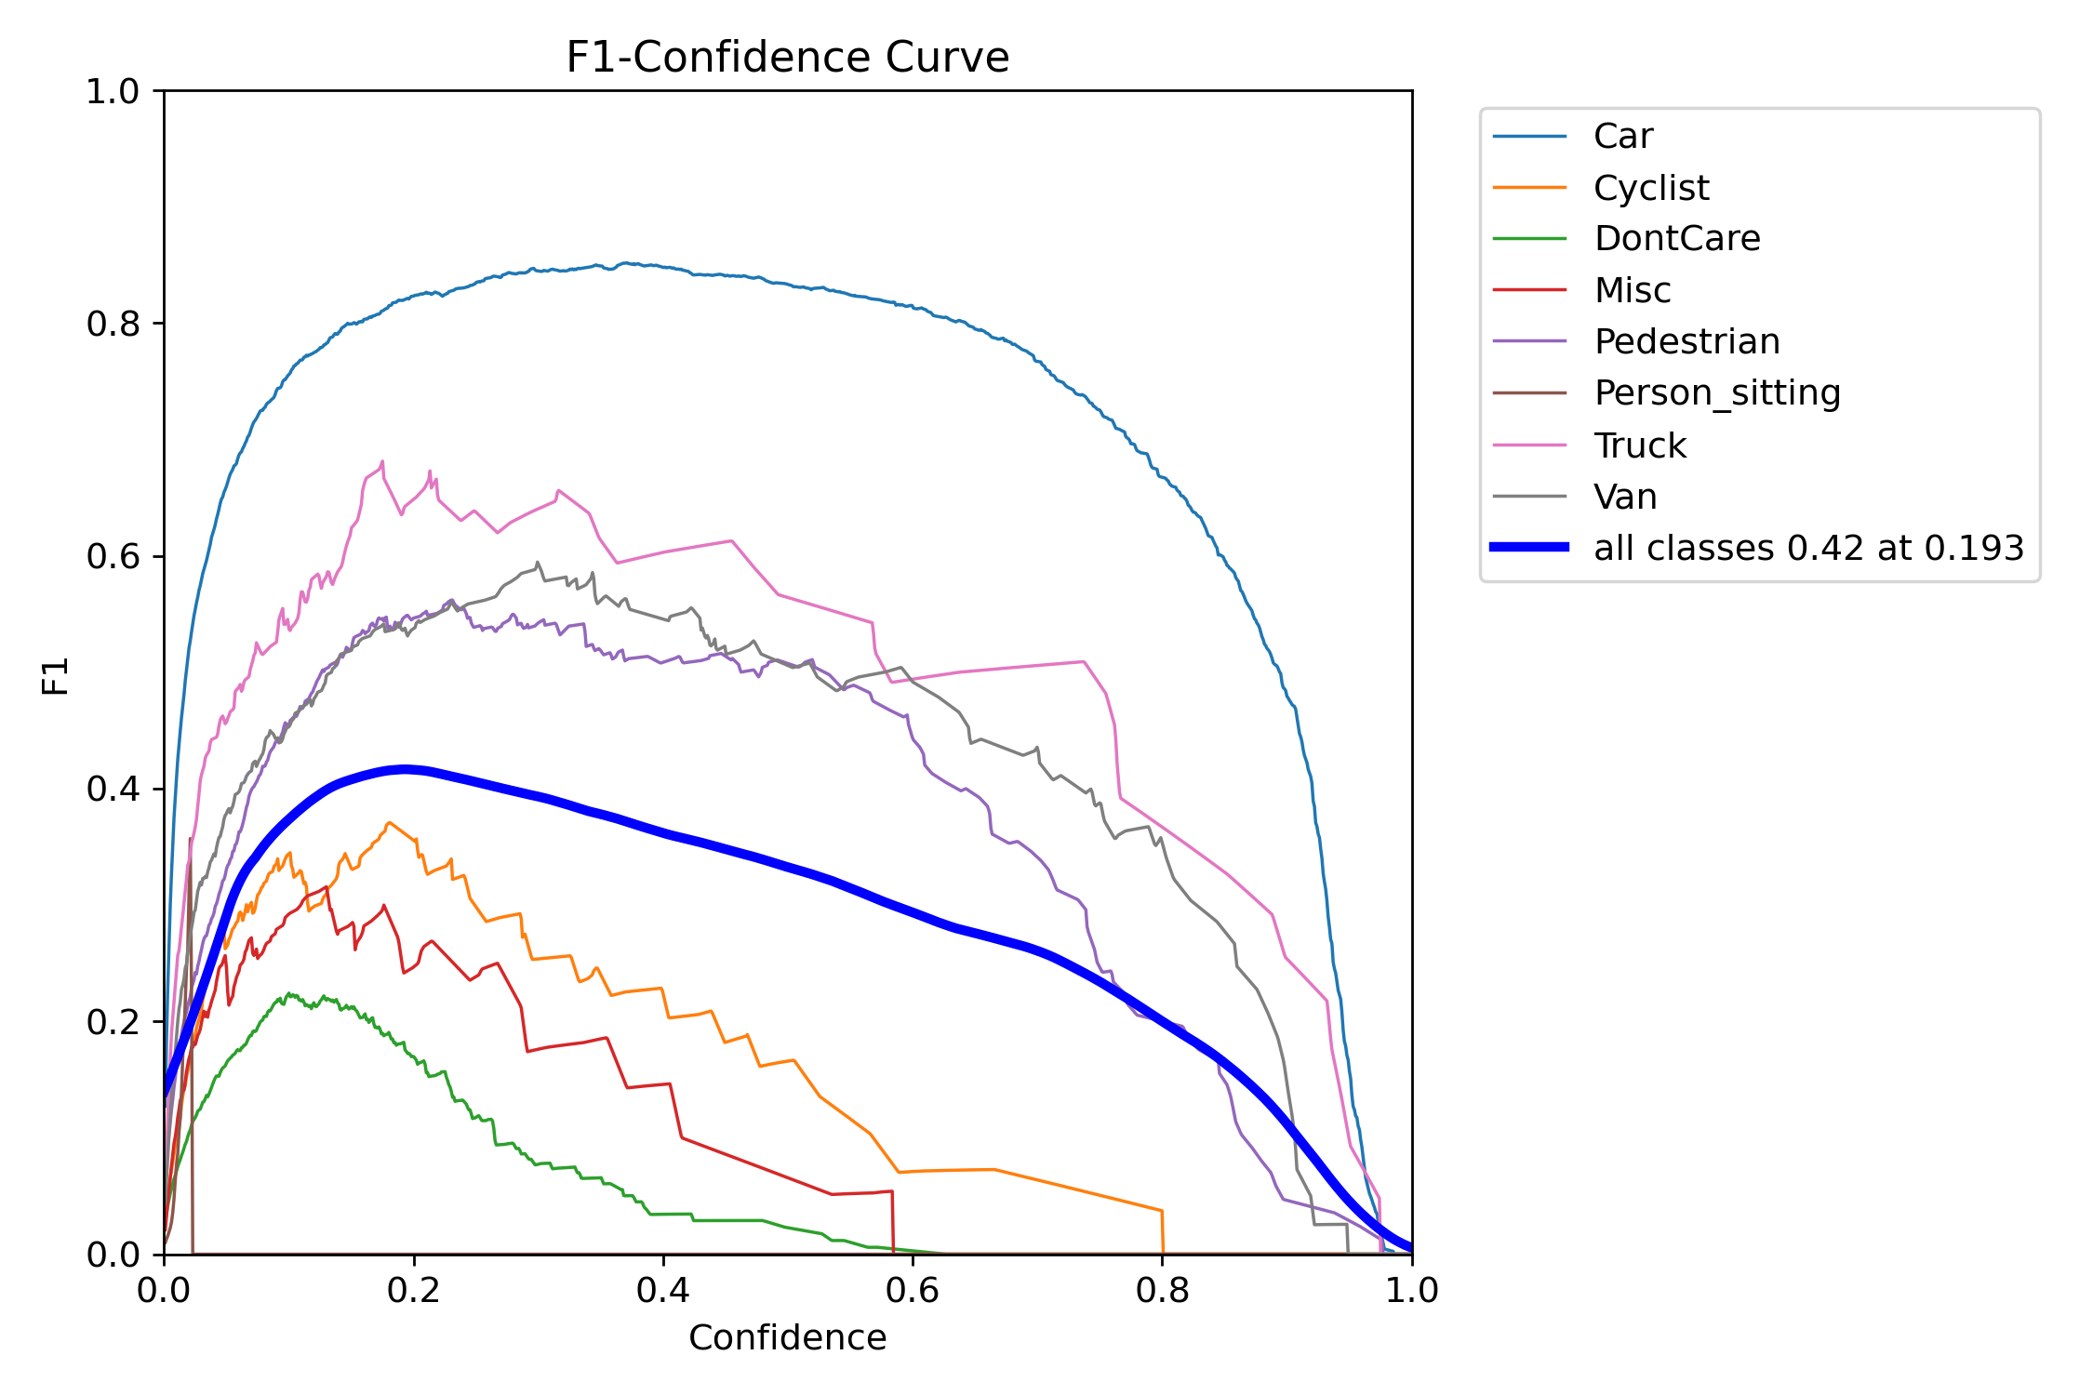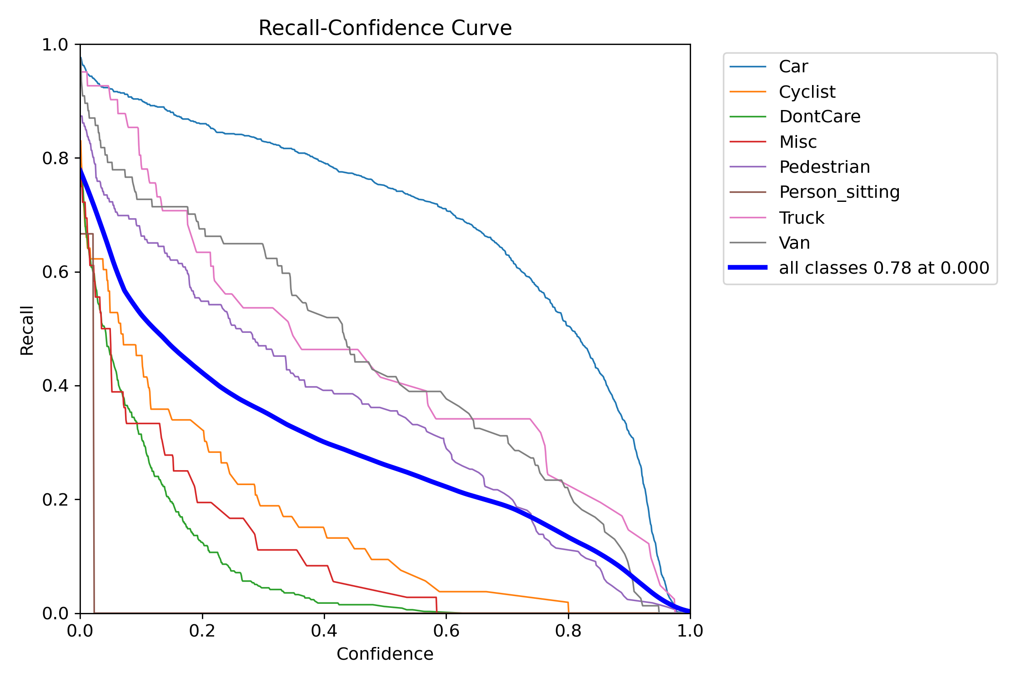

**Training Dynamics and Confusion Matrix Analysis:**

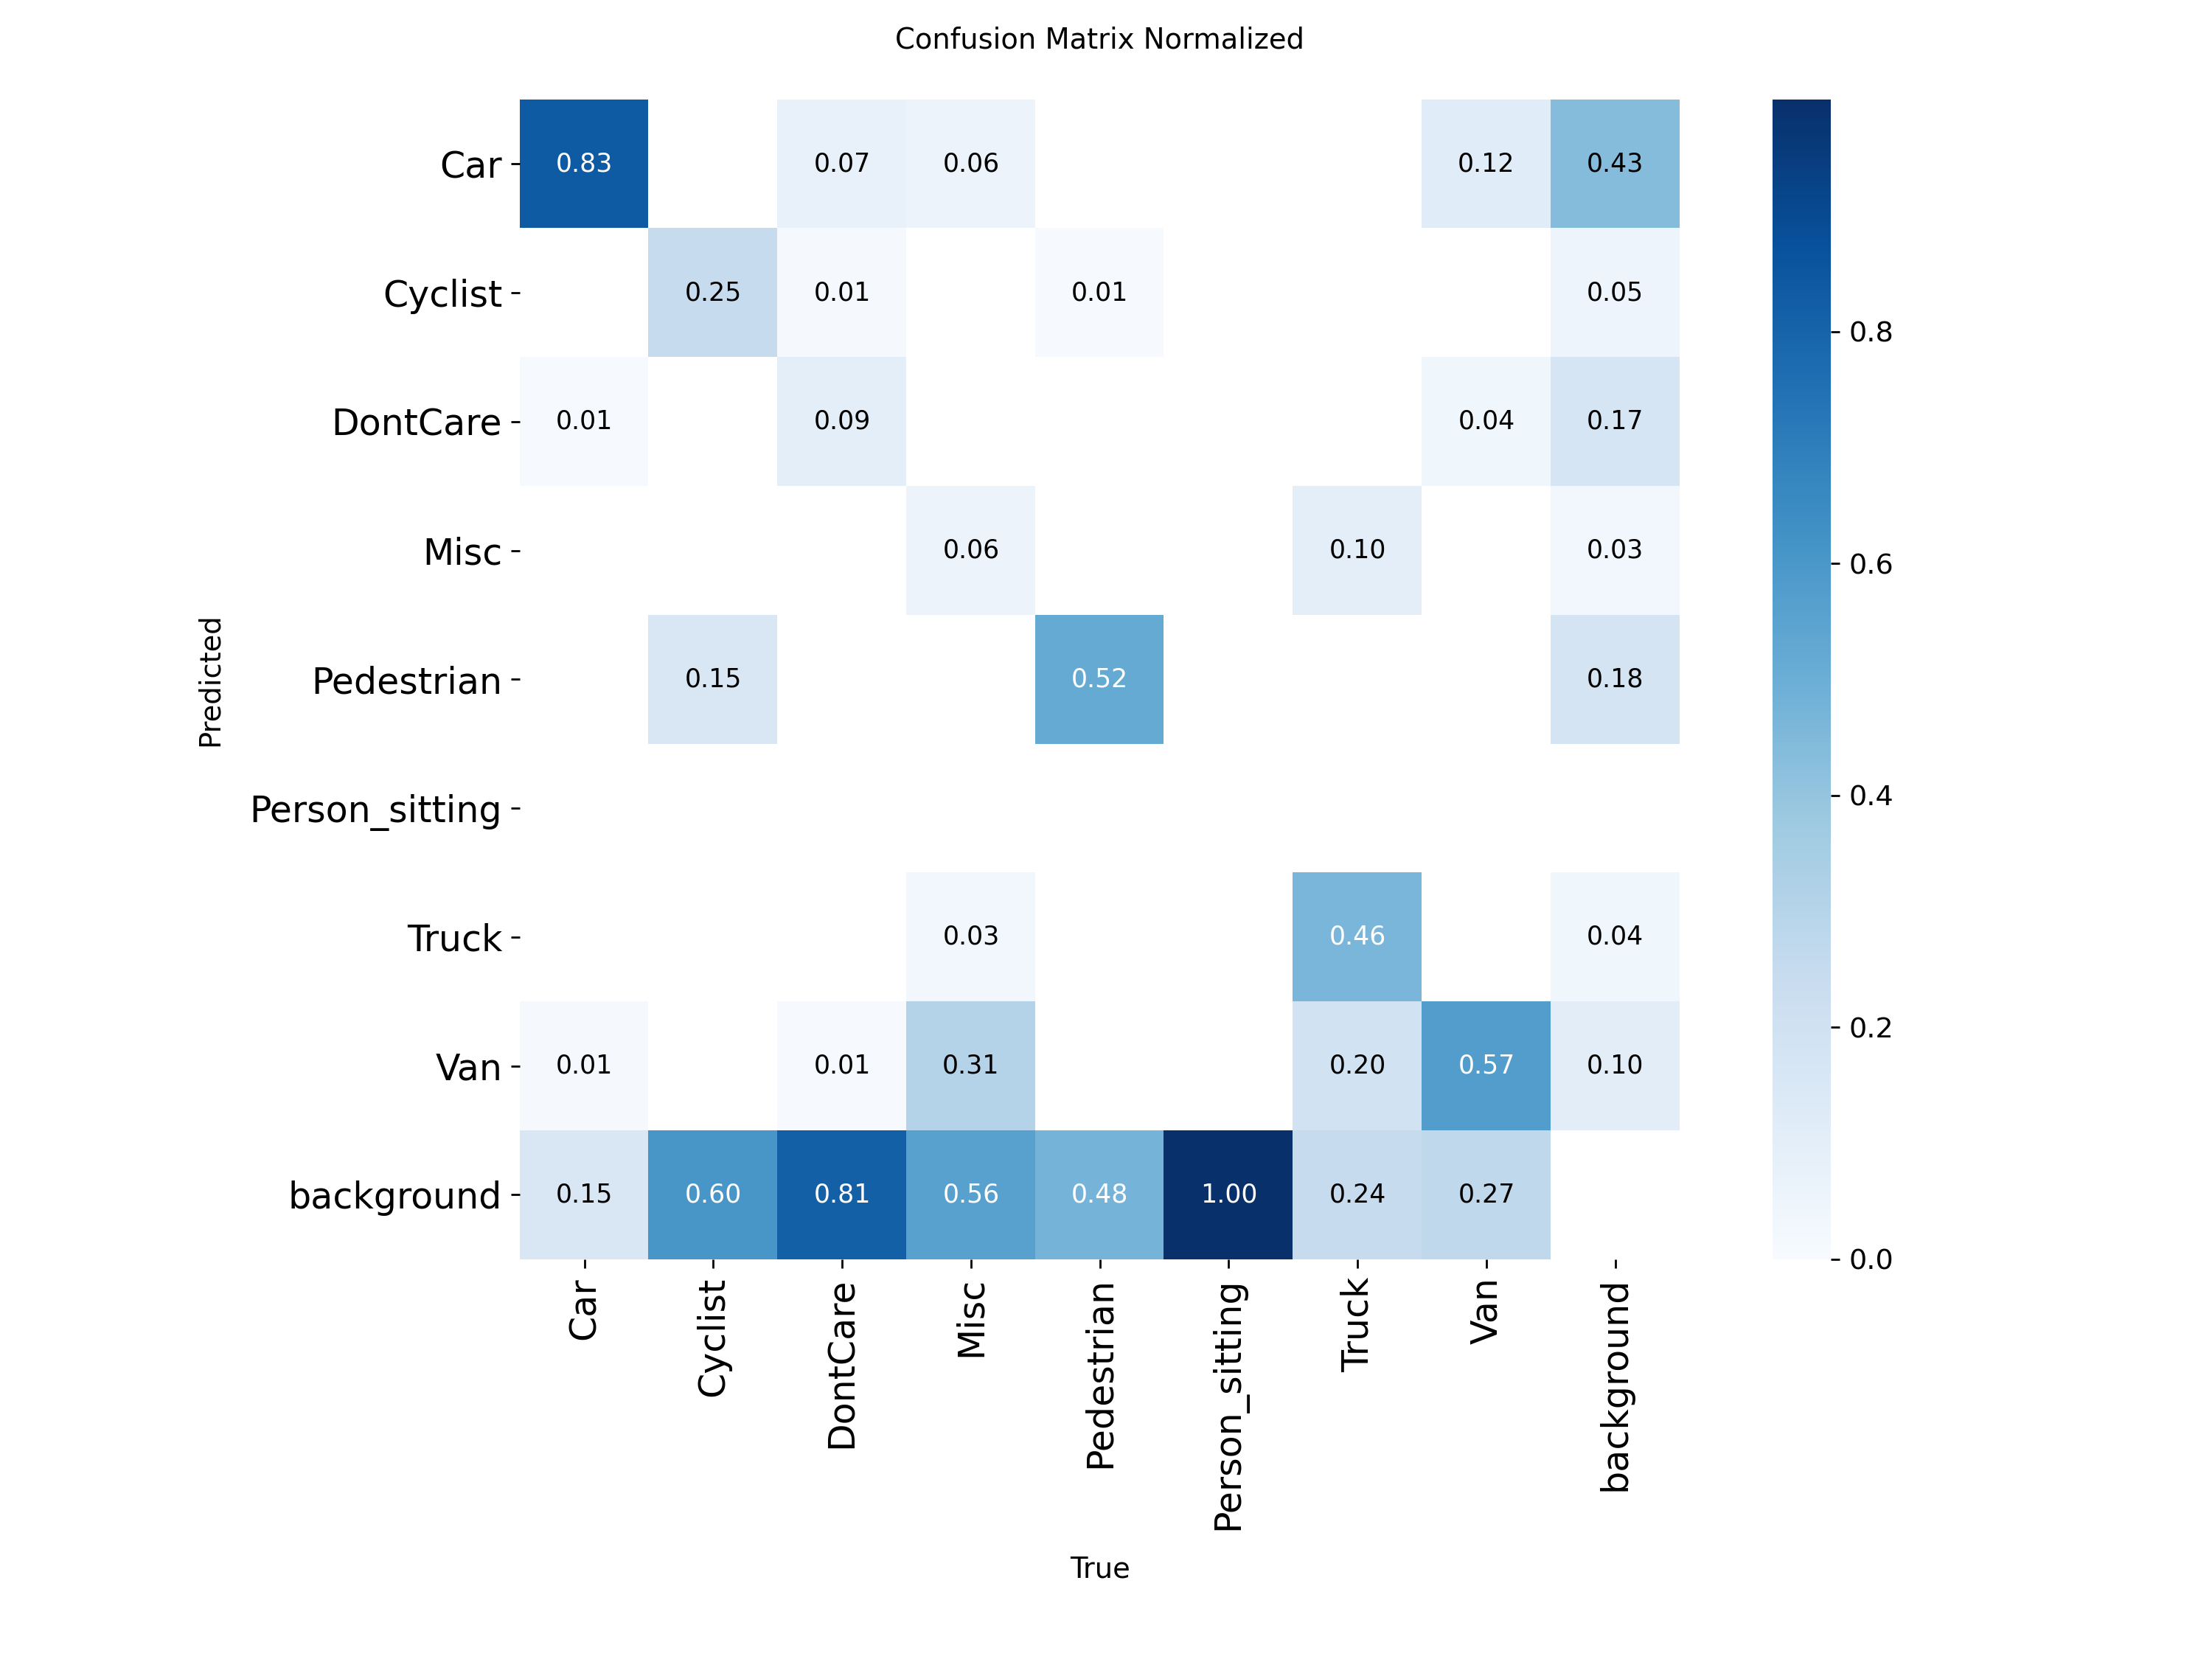

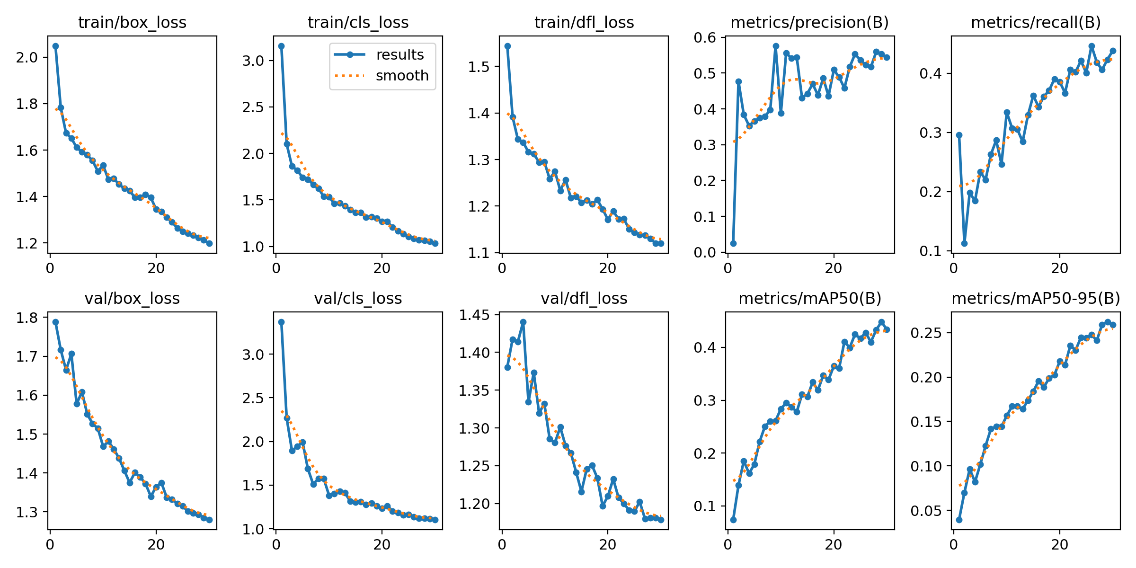

**Bounding Box Spatial Analysis:**

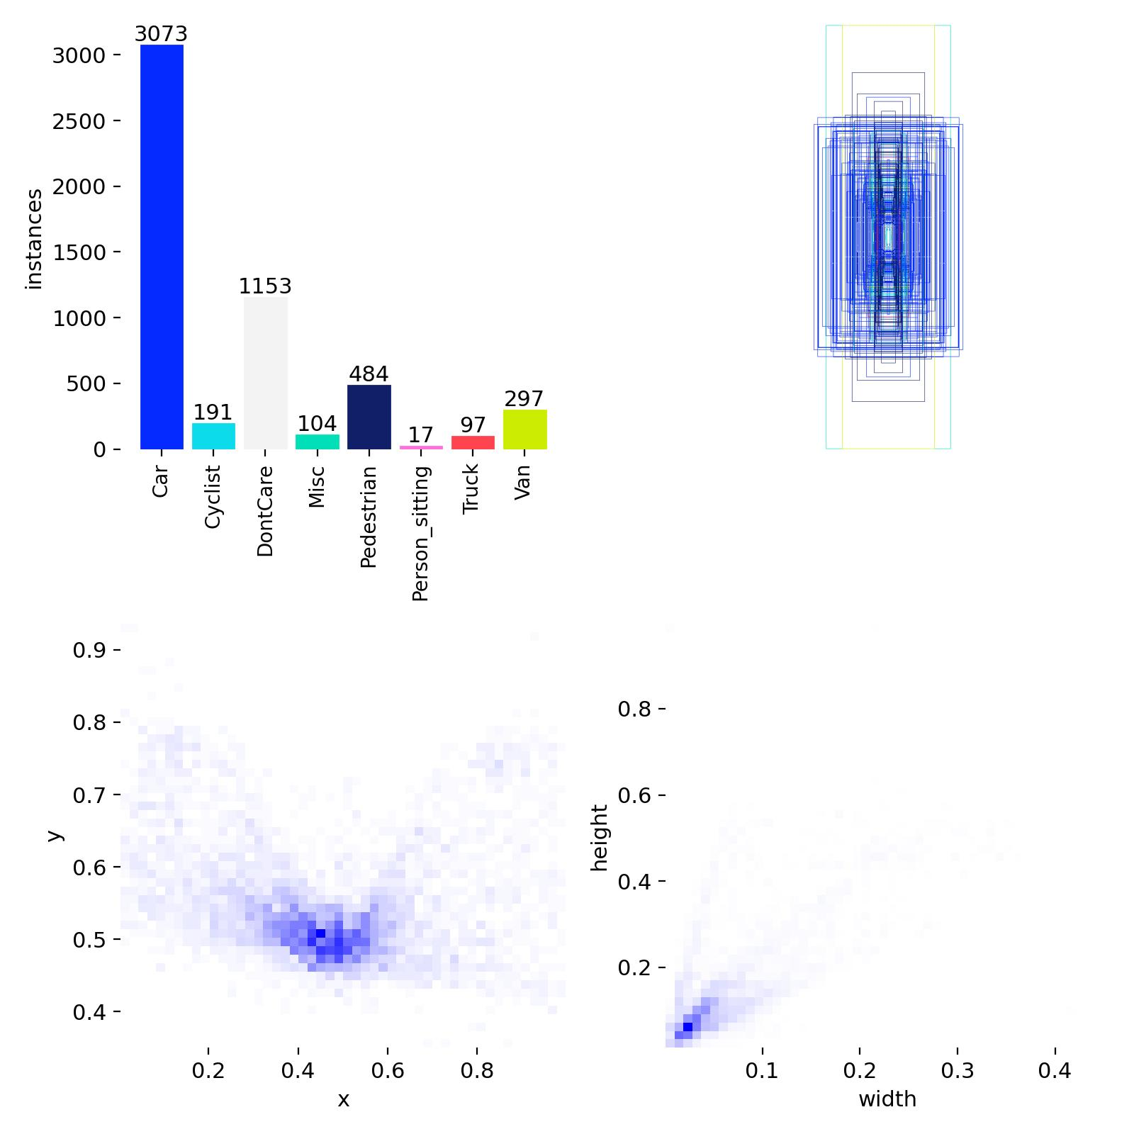

**System Efficiency**

The model achieves strong performance while maintaining low computational overhead due to YOLO’s single-pass detection architecture. This balance between speed and accuracy makes the system suitable for real-world deployment scenarios.

**Future Enhancements**

This system can be extended with lane detection, object tracking, and audio alerts to function as a lightweight driver assistance module.

**Conclusion**

This project presents a real-time perception system that combines object detection with depth-based spatial reasoning. It enhances environmental awareness to support safer and more intelligent vision-driven transportation solutions.